League of Legends

Champion database

By Brad Huntington

12/2/13

Table of contents

Executive Summary 3

**Entity Relationship Diagram4**

**Table Create Statements 5**

**League Champions5**

**Rolls6**

**Champion roll7**

**Item Counters8**

**Champion item Counters9**

**Lane10**

**Champion lane11**

**Counters12**

**Champion counter13**

**Views14**

**Reports & Queries15**

Stored Procedures16

Triggers17

Security18,19

Implementation Notes 20

Known Problems 21

Future Enhancements 22

Executive Summary

This database is designed to aid in champion selection for League of Legends a Multi Player Online Battle Arena. In a typical league of legends match, there will be two teams of five and at the start of the match each player more commonly referred to as “Summoner” will chose his champion. The purpose of this database is to make it easier for a player to counter pick the enemy team’s champions. The database allows strategic game data to be stored such as: champion names, specific roles each champion can satisfy, items that counter champions in game, typical lanes that each champion goes to, and champions that will gain the advantaged when matched up against other champions.

Entity Relationship Diagram

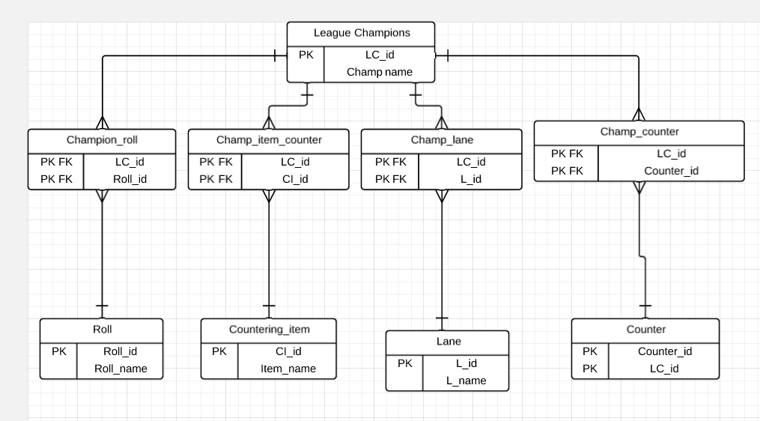

Table Create Statements

League Champions Table

Table create statements



The League Champions table has one unique field, Champ_name. This field paired with the LC_id will help us keep track of the champions.

Functional dependencies



LC_id🡪Champ_name

Create Statement

drop table if exists League_champions;



create table if not exists League_champions

(

LC_id CHAR(5) NOT NULL,

Champ_name TEXT NOT NULL,

Primary key (LC_id)

);

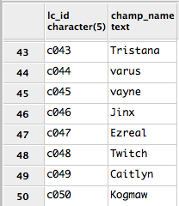Sample data



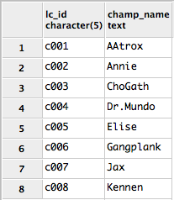

Roll Table



The Roll table has one unique field, Roll_name. This field paired with the Roll_id will help us keep track of the champion rolls.

Functional dependencies



Roll_id🡪Roll_name

Create Statement

drop table if exists Roll;



create table if not exists Roll

(

Roll_id CHAR(4) NOT NULL,

Roll_name TEXT,

Primary key (Roll_id)

);

Sample data



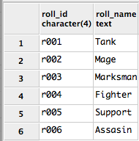

Champion Roll Table



The Champion Roll table has no unique fields. Its primary purpose is to eliminate the many to many relationship of Champions and Rolls. This table will link each champion id to a roll id.

Functional dependencies



None

Create Statement

drop table if exists Champion_roll;



create table if not exists Champion_roll

(

LC_id CHAR(5) not null REFERENCES League_champions (LC_id),

Roll_id CHAR (5) not null REFERENCES Roll (Roll_id),

primary key (LC_id, Roll_id)

);

Sample data



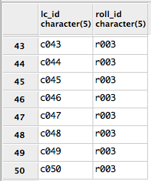

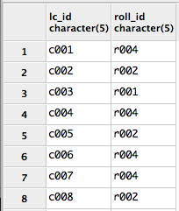

Cou

Countering item Table



The Countering item table has one unique field, Countering_item_name. This field paired with the CI_id will help us keep track of some key items made specifically to counter certain types of champions.

Functional dependencies



CI_id🡪Countering_item_name

Create Statement

drop table if exists Countering_item;



create table if not exists Countering_item

(

CI_id CHAR(6) NOT NULL,

Countering_item_name TEXT,

Primary key (CI_id)

);

Sample data



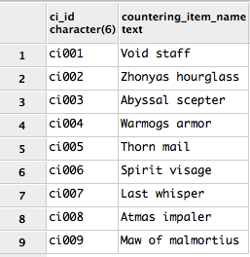

Champion Item Counter Table



The Champion item counter table has no unique fields. Its primary purpose is to eliminate the many to many relationship between Champions and countering items. This table will link each champion with three specific items that counter the champion’s role.

Functional dependencies



None

Create Statement

drop table if exists Champion_item_counter;



create table if not exists Champion_item_counter

(

LC_id CHAR(5) not null REFERENCES League_champions (LC_id),

CI_id CHAR (5) not null REFERENCES Countering_item (CL_id),

primary key (LC_id, CL_id)

);

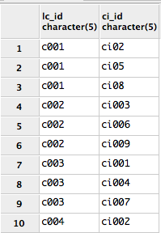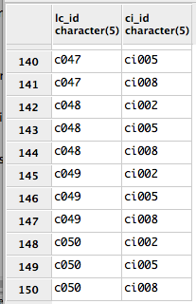Sample data



Lane Table



The Lane table has one unique field, Lane_name. This field paired with the L_id will help us keep track of the Lanes that each champion can go to.

Functional dependencies



L_id🡪Lane_name

Create Statement

drop table if exists Lane;



create table if not exists Lane

(

L_id CHAR(4) NOT NULL,

Lane_name TEXT,

Primary key (L_id)

);

Sample data



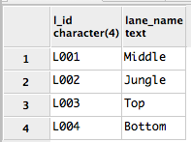

Champ lane Table



The Champ lane table has no unique fields. Its primary purpose is to eliminate the many to many relationship between Champions and lane table. This table will link each champion id to the id of the lanes that the champion is viable to be played in.

Functional dependencies



None

Create Statement

drop table if exists Champ_lane;



create table if not exists Champ_lane

(

LC_id CHAR(5) not null REFERENCES League_champions (LC_id),

L_id CHAR (5) not null REFERENCES Lane (L_id),

primary key (LC_id, L_id)

);

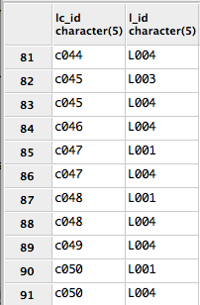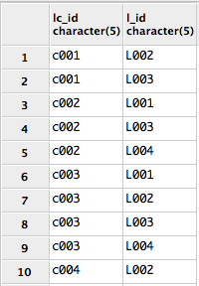Sample data



Counter Table



The Counter table has no unique fields. Its primary purpose is to assign a Counter id to each champion so that it may be referenced in the Champion counter table.

Functional dependencies



None

Create Statement

drop table if exists Counter;



create table if not exists Counter

(

LC_id CHAR(5) not null REFERENCES League_champions (LC_id),

Counter_id CHAR (5) NOT NULL,

primary key (LC_id,Counter_id)

);

Sample data



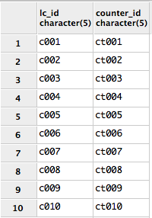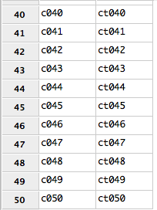

Champ Counter Table



The Champ counter table has no unique fields. Its primary purpose is to take an assigned Counter id from the counter table and link it to a champion id. This links each champion to a countering champion.

Functional dependencies



None

Create Statement

drop table if exists Champ_counter;



create table if not exists Champ_counter

(

Counter_id CHAR (5) not null,

LC_id CHAR(5) not null REFERENCES League_champions (LC_id),

primary key (LC_id, Counter_id)

);

Sample data



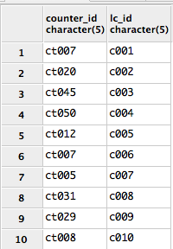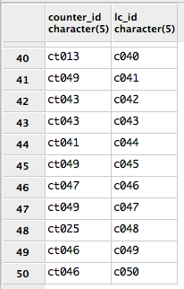

Views

**This view uses the whole database to bring useful information to the person picking a champion. The user will be supplied with the champion name, the roll of the champion, the items that counter the champion, and the champion counter.**

**Create View super_query as**

SELECT DISTINCT

lc.LC_id, lc1.Champ_name,

r.roll_name, l.Lane_name,

CI.countering_Item_name,

c.LC_id, lc2.Champ_name

FROM

Champ_lane cl, lane l,

Champion_item_counter cic,

Countering_item ci, Champion_roll cr,

Roll r, Champ_Counter cc,

League_champions lc, League_champions lc1,

League_champions lc2, counter c

WHERE

r.Roll_id=cr.Roll_id

AND cr.LC_id=lc.LC_id

AND c.Counter_id=cc.counter_id

AND cc.LC_id=lc.LC_id

AND cc.LC_id = lc1.lc_id

AND c.LC_id = lc2.lc_id

AND ci.CI_id=CIC.CI_id

AND cic.LC_id=lc.LC_id

AND l.L_id=cl.l_id

AND cl.LC_id=lc.LC_id

ORDER BY

lc.LC_id

**These four reports will be helpful to any Summoner that wishes to learn more specific aspects each champion.**

Reports and Queries

**This query will generate the name of the champion along with specific items that counter the champion.**

Select distinct

lc.LC_id,

lc.Champ_name,

CI.countering_Item_name

from
Champion_item_counter cic,

League_champions lc,

Countering_item ci

where

CI.CI_id=CIC.CI_id

AND

CIC.LC_id=lc.LC_id

order by
lc.LC_id

**This query will generate the Champion name and the roll that the champion fulfills.**

Select distinct

lc.LC_id,

lc.Champ_name,

r.Roll_name

from

Champion_roll cr,

League_champions lc,

Roll r

where

r.Roll_id=cr.Roll_id

AND

cr.LC_id=lc.LC_id

order by
lc.LC_id

**This query will generate the name of the champion along with specific counter picks of the champion**

select distinct

lc.LC_id, lc1.Champ_name,
c.LC_id,

lc2.Champ_name

from

Champ_Counter cc,
League_champions lc,

League_champions lc1,

League_champions lc2,

counter c

where
c.Counter_id=cc.counter_id

AND
cc.LC_id=lc.LC_id

and
cc.lc_id = lc1.lc_id

and
c.lc_id = lc2.lc_id

order by
lc.LC_id

**This query will generate the name of the champion along with specific Lanes the champion is viable to be played in.**

Select distinct

lc.LC_id,

lc.Champ_name,

l.Lane_name

from

Champ_lane cl,

League_champions lc,

lane l

where

l.l_id=cl.l_id

AND

cl.LC_id=lc.LC_id

order by
lc.LC_id

Stored procedures

**This stored procedure gives helpful champion data. It will return the champion name, the role the champion plays and the lane the champion goes to.**

CREATE FUNCTION CHAMP_INFO (Champ_name text)

returns table (Champ_name text, roll_name text, lane_name text) as $$

select

lc.Champ_name, r.Roll_name, l.lane_name

from

Champ_lane cl, lane l, League_champions lc, Champion_roll cr, roll r where

r.Roll_id=cr.Roll_id

AND cr.LC_id=lc.LC_id

AND l.l_id=cl.l_id

AND cl.lc_id=lc.lc_id

$$ language 'sql';

select * from CHAMP_INFO('Champ_name')

**The following trigger calls this stored procedure, it checks to see if a champion has an empty value in the role field.**

CREATE

FUNCTION new_data_check()

returns trigger as $$

BEGIN if (roll_id is null)

Then

UPDATE

set Roll_id = 'NA'

where Roll_id = null;

END

$$language plpgsql;

Triggers

**This trigger is used when a new champion is entered into the database. Once a new champion is released it takes a while to determine certain characteristics. For example, what roll the champion will excel at. Therefore we need to fill in potential missing data.**

CREATE

trigger New_champion_data_check

After insert

on

champion_roll,

for each row

execute new_data_check

Security

**To ensure security we make a user and an admin. The Admin’s control over the database is unconstrained while the user can only view data.**

SQL Code for security



CREATE USER League_admin WITH PASSWORD ‘alpaca’

Grant Select, update, delete, insert on League_champions to League_admin

Grant Select, update, delete, insert on Champ_counter to League_admin

Grant Select, update, delete, insert on Champ_lane to League_admin

Grant Select, update, delete, insert on Champion_item_counter to League_admin

Grant Select, update, delete, insert on Champion_lane to League_admin

Grant Select, update, delete, insert on Counter to League_admin

Grant Select, update, delete, insert on Countering_item to League_admin

Grant Select, update, delete, insert on Lane to League_admin

Grant Select, update, delete, insert on Roll to League_admin

-- This code will give the user League_admin all the unrestricted access to the database

CREATE USER League_user WITH PASSWORD ‘alpaca’

Revoke all on League_champions from League_user

Revoke all on Champ_counter from League_user

Revoke all on Champ_lane from League_user

Revoke all on Champion_item_counter from League_user

Revoke all on Champion_lane from League_user

Revoke all on Counter from League_user

Revoke all on Countering_item from League_user

Revoke all on Lane from League_user

Revoke all on Roll from League_user

Grant Select on League_champions from League_user

Grant Select on Champ_counter from League_user

Grant Select on Champ_lane from League_user

Grant Select on Champion_item_counter from League_user

Grant Select on Champion_lane from League_user

Grant Select on Counter from League_user

Grant Select on Countering_item from League_user

Grant Select on Lane from League_user

Grant Select on Roll from League_user

Implementation Notes

* Implementation is as easy as copying the tables provided.
* Once tables are created, all that needs to be done is insert desired champion data.
* The 67 not included champions may also be added into the database before implementation.

Known Problems

* The amount of champions is always growing the space provided by LC_id (league Champion) and Counter_id will be insufficient if the number of champions grows past 999.
* As a result of the ever growing champion pool new items are inserted and removed from the game in order to balance the power of all champions, if an item on the countering item list were to be removed it would effect multiple tables.

Future Enhancements

* Currently the database includes only critical data to allow the user to make an educated decision in champion selection, however in the future more non-critical data could be added.
  + Specific Champion spells
  + Summoner spells
  + 168 more items could be added
* The rest of the champions should be added to complete the database
* Triggers for every table will be implimented
* Multiple Champion counters and countering items should be added in order to supply the user with more data and allow people to have a choice when choosing a countering champion